Part 1: HashCAt

Step 1 downloading hcxdumptool and hcxtools

Step 2 Use Hxcdump to Capture PMKIDs from Local Networks

Step 3 Use Hxcpcaptool to Convert the Dump for Hashcat

Step 4 Select a Password List & Brute Force with Hashcat

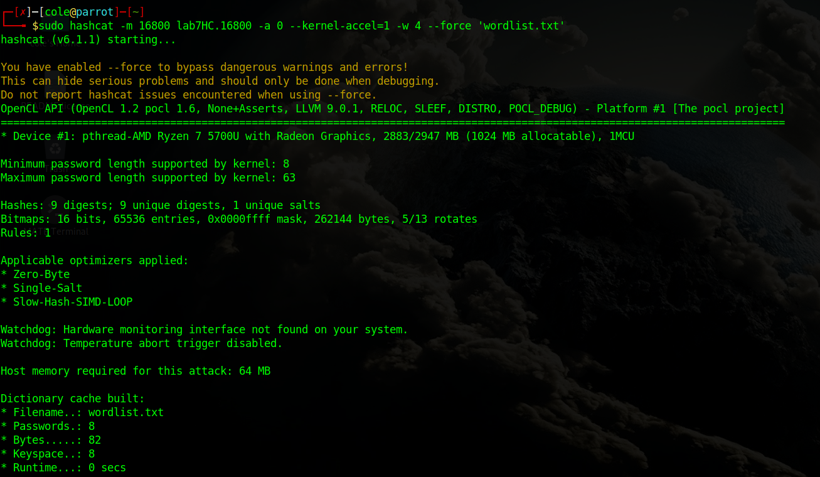

Unfortunately the wordlist was unable to crack the password but the concept is all here.

Part 2: Wi-Fi Jamming Detection

Part 1 Prepare Your Network Card

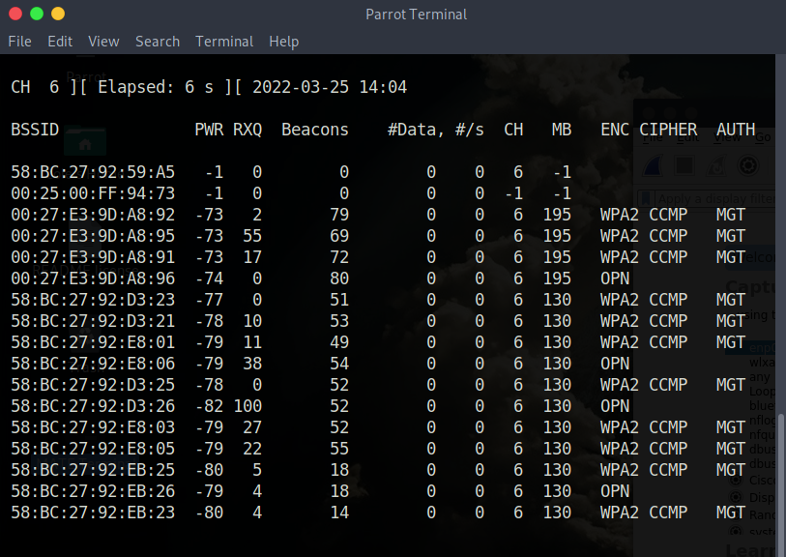

Part 2 Setting up Color Filters

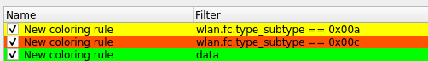

Part 3 Capture Filters in Wireshark and Display Filtering, Which Is Different for Some Reason

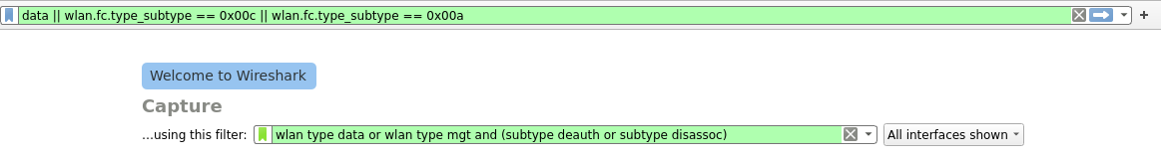

Part 4 Classify Common Script-Kiddie Tools

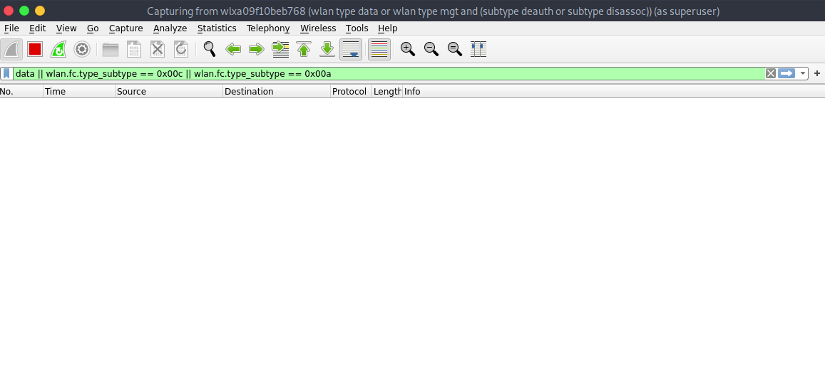

Unfortunately no packets were captured by wireshark, I double checked and the filters should be correct so I do not know how to fix this issue. I am unable to continue to the final steps after this.